1. Title
Visual Memory Recall Test – User Interface Design Project

2. Introduction
Visual Memory Recall is the ability of users to remember images, shapes, colors, and visual patterns after briefly seeing them. This project focuses on designing a user-friendly interface that evaluates a user’s visual memory through a simple and interactive shape-based recall test. The interface is designed using Figma with emphasis on clarity, minimal cognitive load, and intuitive interaction.

3. Objective
- To design a clean and interactive UI for testing visual memory.
- To apply UI/UX principles such as consistency, contrast, spacing, and visual hierarchy.
- To create a simple recall-based task using shapes.
- To measure user memory performance through a score screen.

4. Problem Statement
Many memory testing tools are text-heavy or visually cluttered, which increases cognitive load and reduces usability. Users need a simple, distraction-free interface to test and improve their visual recall ability. This project aims to design a minimal and intuitive visual memory testing interface.

5. Target Users
- Students
- Cognitive training learners
- UI/UX experiment participants
- General users interested in memory testing

6. Design Tool Used
- Figma – for UI design and prototyping
- Frame-based layout for multiple screens
- Shape components for test objects

7. Design Principles Applied
- Consistency – Same color palette and typography across screens
- Visual Hierarchy – Title at top, content centered, actions at bottom
- Contrast – Dark shapes on light purple background
- Minimalism – No unnecessary text or distractions
- Affordance – Button clearly indicates clickable action
- Spacing & Alignment – Evenly spaced shapes and centered layout

8. Color Scheme
- Primary Background: Light Purple
- Accent Header Box: Light Cyan
- Shapes: Dark Purple
- Button: Soft pastel with shadow for visibility
Reason: Soft colors reduce visual stress and help focus on shapes.

9. Typography
- Clear readable heading font
- Larger font size for titles
- Medium font size for instructions
- Large bold font for score display

10. Screen Flow Description
Screen 1 — Introduction Screen
- Title: Memory Visual Recall
- Description of what visual memory is
- Short explanation of purpose
- “Start Test” button
- Acts as onboarding screen
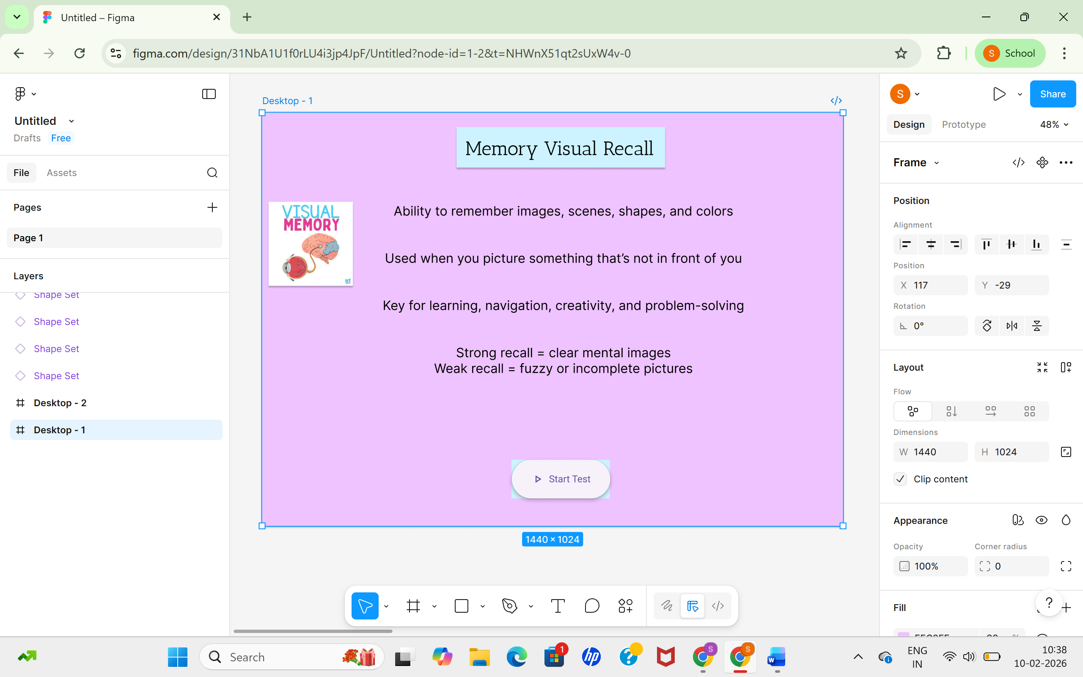

Screen 2 — Shape Display Screen
- Title: Visual Memory Test
- Multiple shapes displayed
- User observes shapes
- No interaction yet
- Focus on memory encoding stage
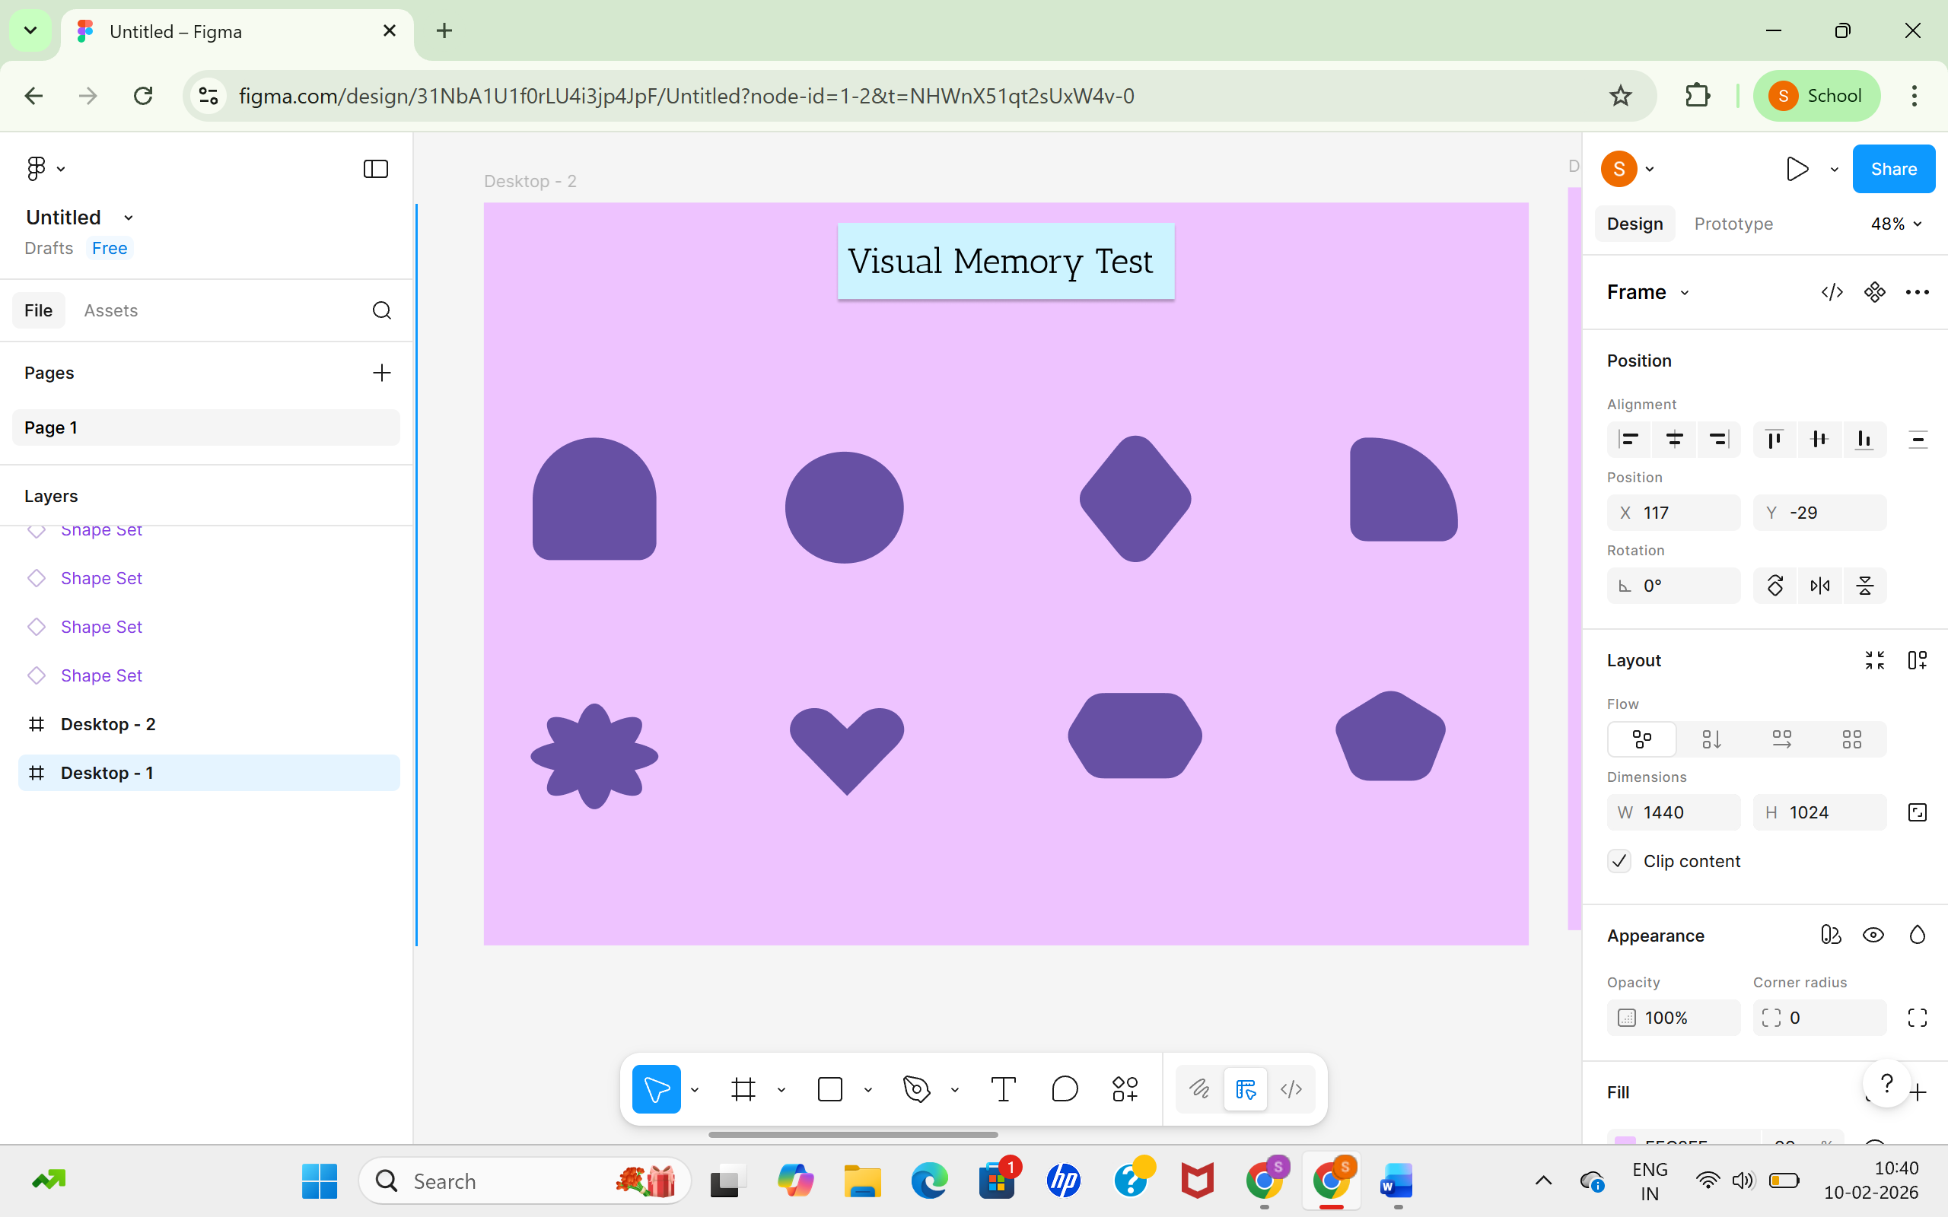

Screen 3 — Recall Selection Screen
- Same or mixed shapes shown
- User selects shapes they remember
- Checkbox indicators below shapes
- Interactive recall stage
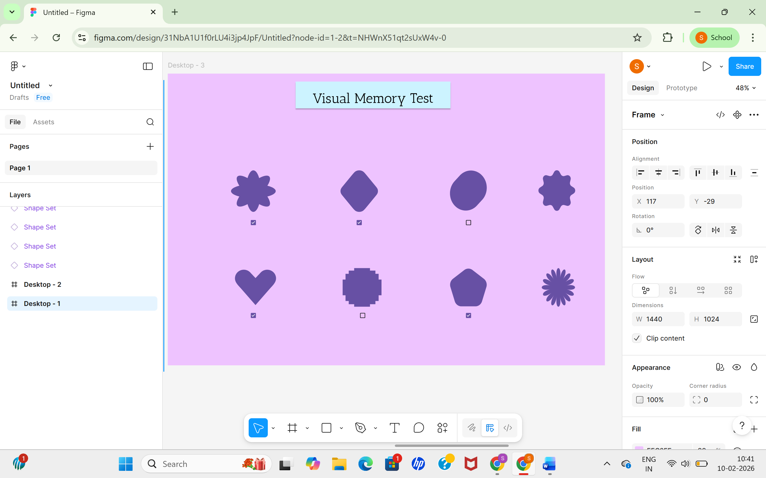

Screen 4 — Result Screen
- Displays score (example: 4/4)
- Immediate feedback
- Clean and centered layout
- Reinforces user performance
